The Difference of Traditional Fishing Boats in Blimbing and Brondong Sub-districts, Lamongan, Indonesia

Y Praharsi1*, M A Jami’in1, G Suhardjito1 and H M Wee2

1Shipbuilding Institute of Polytechnic Surabaya (Politeknik Perkapalan Negeri Surabaya) Jl. Teknik Kimia, Kampus ITS, Sukolilo Surabaya 60111, Indonesia

2Department of Industrial and System Engineering Chung Yuan Christian University Chung Pei Road No. 200, Chungli City 32023, Taiwan.

*yugowati@ppns.ac.id

**Abstract**. There are 17 fisherman’s offices in Lamongan regency whose record the data of traditional fishing boats. However, there are only two fisherman’s offices whom very active, i.e.: Blimbing and Brondong sub-districts. Blimbing has the data of 394 traditional boats while Brondong has 207 ones. In this study, we compare the Gross Tonnage-Size of traditional boats, the type of fish catching tools, and the frequency distributive between the two sub-districts. The results show that the mean of GT-size in Blimbing and Brondong is 15 GT and 10 GT respectively. The Pareto charts show that more than 50% in Blimbing used trawl while more than 60% in Brondong used fishing rods. We did the hypothesis test for the mean of GT-Size. The results of hypothesis show that there are differences of mean between the two sub-districts. Subsequently, we create the frequency distributive in each district. By this study, it is expected that the data extraction of traditional boats in Blimbing and Brondong gives a comprehensive description and understanding for the standardization of traditional fishing boats.

Introduction

The traditional fishing boat are still used and produced by fishermen in Lamongan regency. Traditional fishing boats are made from wooden [1] [2]. The fishermen build the traditional fishing boats by a heritage technique from their ancestors [3] [4]. Most of the fishermen are registered as a membership among the seventeen fishermen offices. In each office, there is an organization structural including the chief, the secretary, the treasure, the chief of sub divisions in advocacy and law, in development of fish processing, in society service, in training and education for fishermen, in discipline, and members. However, there are only two fishermen offices whose very active organizations, i.e.: Brondong and Blimbing sub-districts. Brondong has 207 members of fishermen while Blimbing has 394 members ones. When our research team visited these two offices, we discussed about the characteristics of traditional fishing boats in both territories [5]. However, they could not explain about the mean of GT size, the majority of fish catching tools used by fishermen, and the data dispersion of their members. This study is motivated by their problem. We aim to extract the data of membership in Brondong and Blimbing sub-districts by the central tendency distribution, the hypothesis testing of mean of GT sizes in both sub-districts, and the frequency distribution table to describe the data dispersion.

In order to describe the data quantitatively, the measurements used in the central tendency distribution are mean, mode, median, quartile 1, and quartile 3. We also consider the data dispersion and use the standard deviation, variance, minimum and maximum values [6] [7]. Subsequently, we test the hypothesis null that the mean of the GT sizes between Brondong and Blimbing sub-districts are the same. Besides, we describe the data in frequency distributive table to observe the data in each class.

The remaining of this paper is organized as follows. Section 2 presents research methodology including sample, design, and proposed hypotheses. Section 3 discusses the results of central tendency distribution, hypothesis test, and frequency distributive table, whereas Section 4 finally presents the conclusions, limitations, and future research directions derived from this paper.

Research Methodology



Figure 1. The research methodology

Based on Figure 1, we start the research by collecting the data primary and secondary. In primary data, we did the interview with the stakeholders of fishermen offices in both sub-districts. In secondary data, we took the raw data of the membership in both fishermen offices. Subsequently, we processed the data by central tendency distribution, data dispersion, and hypothesis testing. We set that there is no difference between mean of GT sizes in Brondong and Blimbing sub-districts in Lamongan regency for the hypothesis null. If this hypothesis is accepted, we mixed the data in both sub-districts to make the frequency distributive table. Otherwise, we make the frequency distributive tables for each sub-district.

Result and Discussion

## Central tendency distribution of Blimbing district

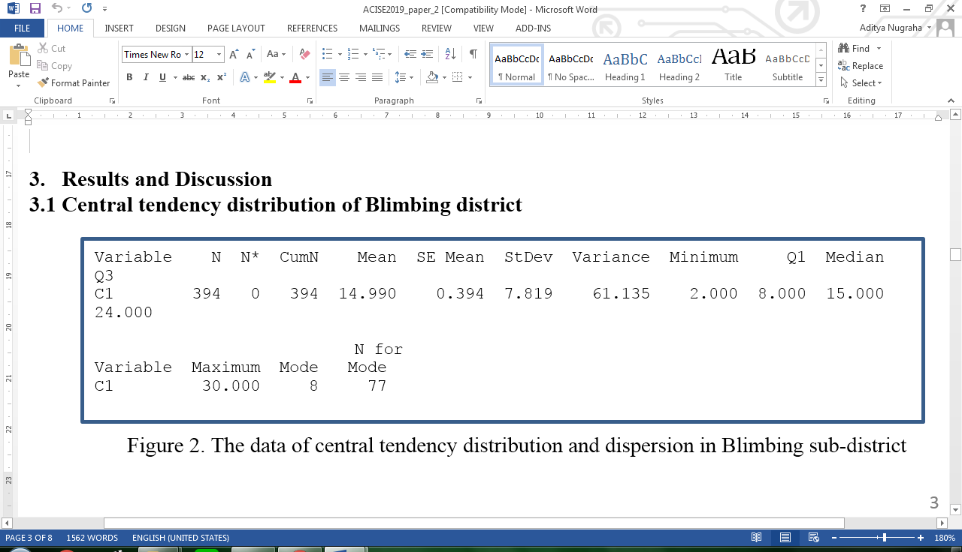

Figure 2. The data of central tendency distribution and dispersion in Blimbing sub-district



Figure 3. Pareto Chart for the mean of GT sizes in Blimbing sub-district



1: Purse seine 3: Trans-shipment 5: Fishing rod

2: Trawl 4: Surrounding net

Figure 4. Pareto chart for the type of fish catching tools in Blimbing sub-district

## Central tendency distribution of Brondong district

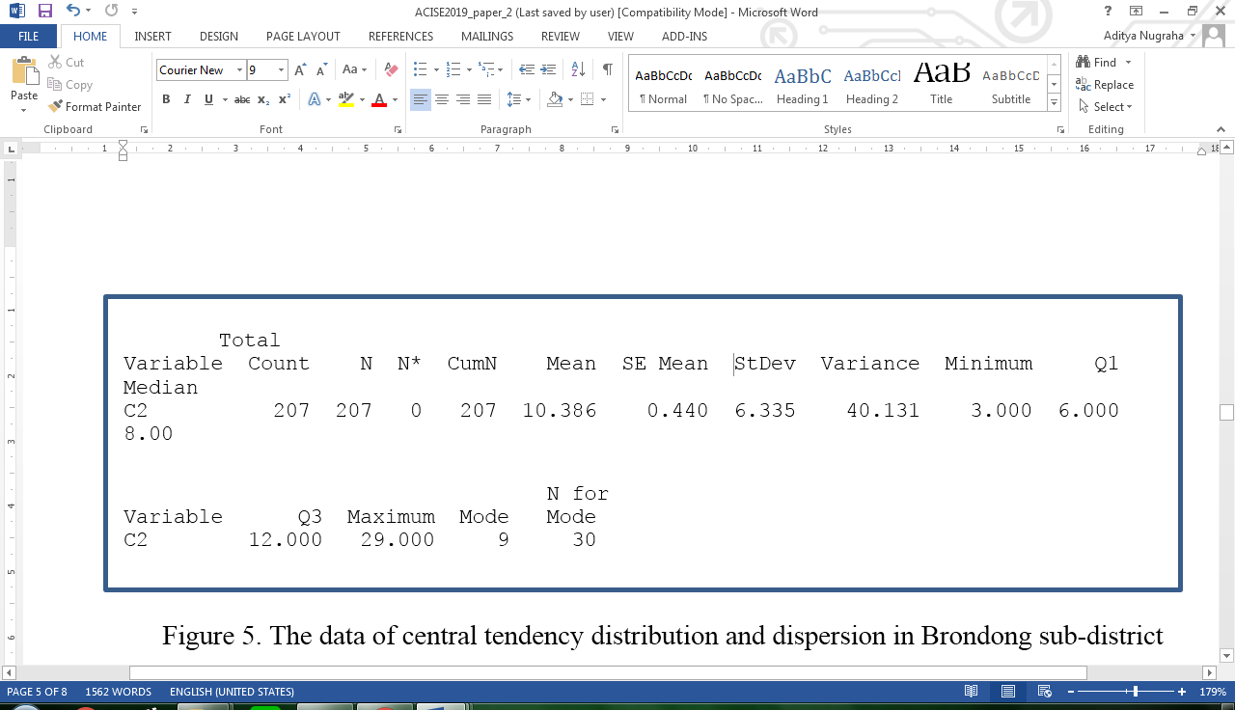

Figure 5. The data of central tendency distribution and dispersion in Brondong sub-district



Figure 6. Pareto chart for the mean of GT sizes in Brondong sub-district



1: Purse seine 3: Trans-shipment 5: Fishing rod 7: Circumference net 9: Gillnet

2: Trawl 4: Surrounding net 6: Mini trawl 8: Long fishing line

Figure 7. Pareto chart for the type of fish catching tools in Brondong sub-district

## Hypothesis testing

H0: (1)

H1: (2)

With the level of significance 5%, we set the hypothesis null that there is no difference of mean GT sizes in Brondong and Blimbing sub-districts.

Based on Figure 8, we reject hypothesis null because the *p-value* is less than 0.05. It means that the mean of GT sizes between Brondong and Blimbing are different. The mean of traditional fishing boat in Brondong is 10 GT, meanwhile the ones in Blimbing is 15 GT. Subsequently, we make the table of frequency distributive based on the data for each sub-district.

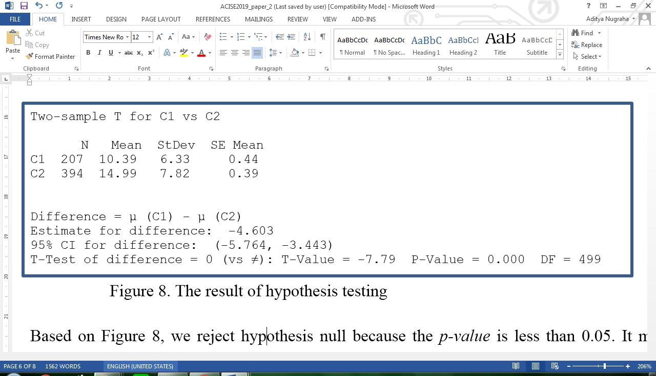

Figure 8. The result of hypothesis testing

## Frequency distribution table

The number of class (*k*) = 1 + 3.3 log (394) = 9,565 = 10

Range = (Xmax - Xmin) = 30 – 2 = 28

The interval (*c* )= (Range + 1)/*k* = ((30-2)+1)/10 = 2,9 = 3

Table 1. The frequency distributive in Blimbing sub-district

|  |  |  |  |
| --- | --- | --- | --- |
| **The size of GT** | **Frequency** | | |
| 1,5 – 4,5 | 1 + 4 + 1 | = | 6 |
| 4,5 – 7,5 | 4 + 28 + 42 | = | 74 |
| 7,5 – 10,5 | 77 + 8 | = | 85 |
| 10,5 – 13,5 | 19 | = | 19 |
| 13,5 – 16,5 | 57 + 4 | = | 61 |
| 16,5 – 19,5 | 15 | = | 15 |
| 19,5 – 22,5 | 26 + 6 | = | 32 |
| 22,5 – 25,5 | 2 + 27 + 42 | = | 71 |
| 25,5 – 28,5 | 1 + 1 + 13 | = | 15 |
| 28,5 – 31,5 | 16 | = | 16 |
| Total | | | 394 |

The number of class (*k*) = 1 + 3.3 log (207) = 8,643 = 9

Range= (Xmax - Xmin) = 29 – 3 = 26

The interval (*c*) = (Range + 1)/*k* = ((29-3)+1) / 9 = 3

Table 2. The frequency distributive in Brondong sub-district

|  |  |  |  |
| --- | --- | --- | --- |
| **The size of GT** | **Frequency** | | |
| 2,5 – 5,5 | 21 + 11 + 8 | = | 40 |
| 5,5 – 8,5 | 14 + 22 + 29 | = | 65 |
| 8,5 – 11,5 | 30 + 5 + 4 | = | 39 |
| 11,5 – 14,5 | 16 + 4 + 1 | = | 21 |
| 14,5 – 17,5 | 1 | = | 1 |
| 17,5 – 20,5 | 5 + 9 | = | 14 |
| 20,5 – 23,5 | 8 + 4 + 3 | = | 15 |
| 23,5 – 26,5 | 8 + 3 | = | 11 |
| 26,5 – 29,5 | 1 | = | 1 |
| Total | | | 207 |

Conclusion

We have described the central tendency distribution, the dispersion, and the hypothesis testing of the data of traditional fishing boat in Brondong and Blimbing sub-districts. Based on the hypothesis testing, the mean of GT sizes in both-sub districts are different. The mean of traditional fishing boats in Brondong sub-district is 10 GT while the ones in Blimbing sub-district is 15 GT. Subsequently, we make the frequency distributive tables for each sub-district to observe the GT sizes in classes. Besides, we also have described the type of fish catching tools. Based on the pareto diagram, more than 50% in Blimbing used trawl fish catching tools while more than 60% in Brondong used fishing rods. By studying the data characteristics in both sub-districts, we expect to help the standardization of traditional fishing boats in East Java. The future research will be carried by multivariate analysis to know the relationship between the GT sizes and the type of fish catching tools.

References

1. Triastuti N S and Soewarno N 2015 *Procedia Engineering*. **125** 899-904
2. Liu W, Demirel Y K, Djatmiko E B, Nugroho S, Tezdogan T, Kurt R E, Supomo H, Baihaqi I, Yuan Z and Incecik A 2019 *International Journal of Naval Architecture and Ocean Engineering*. **11** 380-395
3. Jokosisworo S and Santosa A W B 2008 *Ship Journal-Diponegoro University.* **5** 6-14
4. Trimulyono A, Amiruddin W, Purwanto E D and Sasmito B 2015 *Ship Journal-Diponegoro University* **12** 139-44.
5. Praharsi Y, Jami’in M A, Suhardjito G and Wee H M *International Conference Proceeding on Industrial Engineering and Operations Management*, Pretoria/Johannesburg, South Africa, October 29-November 1, 2018, ISSN: 2169-8767, ISBN: 978-1-5323-5947-7
6. Nasution M N 2015 *Total Quality Management* (Bogor: Ghalia Indonesia)
7. Lind D A, Marchal W G and Wathen S A 2013 *Statistical Techniques in Business and Economics* (Jakarta: Salemba Empat)